Training Overview
This Training Guide walks you through the fundamental steps you need to begin designing templates with Windward Designer in Microsoft Word using an XML Datasource.
The Four Steps to Windward:
1. Install
2. Connect to data
3. Design your template & insert your data
4. Output
Step 1 – Install
To get started, you need to install the Designer. If you have it already installed, please skip this step!
To install the Designer, please visit the downloads page:
https://www.windwardstudios.com/version/version-downloads
Step 2 - Connect To Data
In this training guide, you are connecting to a sample XML Datasource provided by Windward. To connect to the sample data:
- Open Microsoft Word. Now that you’ve installed Windward Designer, you will see two new tabs in the Microsoft Office Ribbon – the “Windward” Tab and the “Windward Tools” Tab.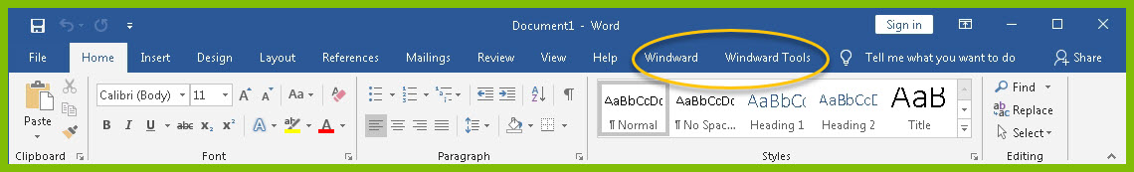
2. Click on the “Windward Tab” and click on the “Data Sources” button located on the left-hand side of the ribbon. This opens the Connection Editor where you will manage all of your data connections.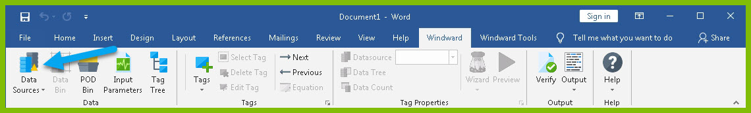
3. In the Connection Editor window, select the data connection labeled “XML” under “Recent Inactive” and click the “Connect” button.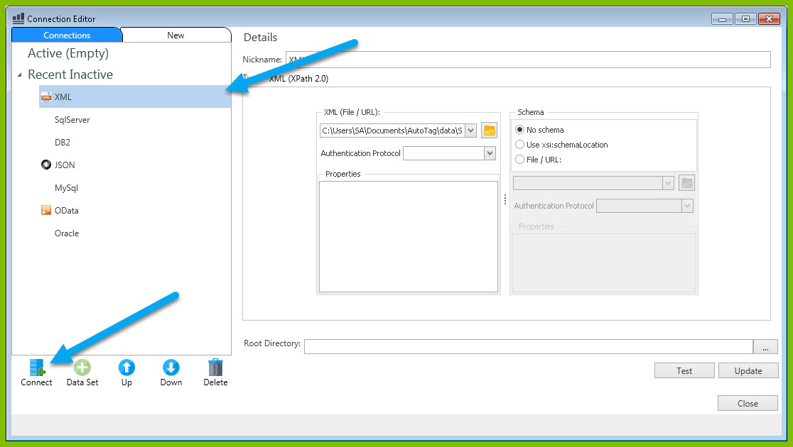
4. Close the Connection Editor by clicking “Close.” You have now successfully connected to the sample data!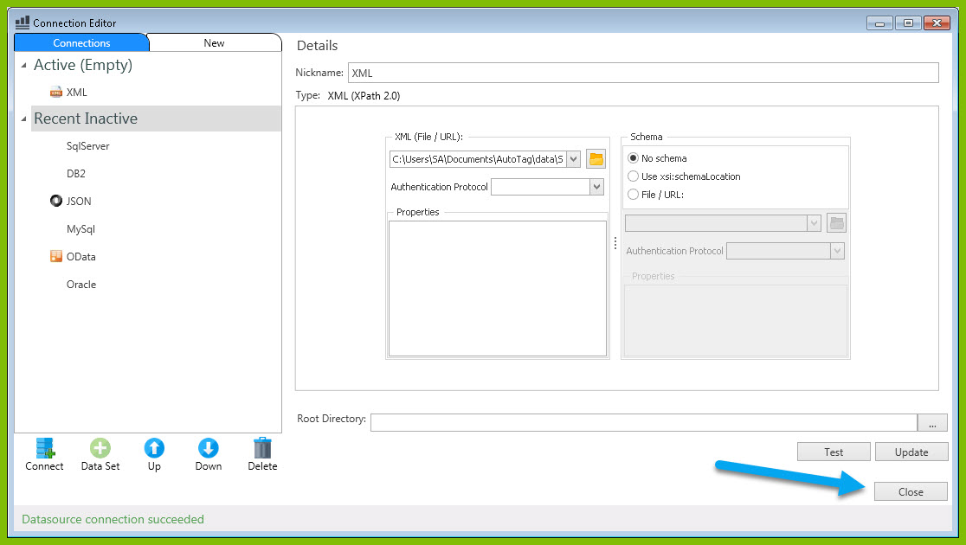
Step 3 – Design Your Template & Insert Your Data
In this training guide, you will build a very basic template to get the feel of Windward Designer. While your final product may not seem very impressive, you will learn the basic skills to making any template! You will make a template which will output the product name and unit price for every product in the sample data, with each product separated by a line.
Your first step is to place a ForEach tag in your template. This tag will allow you to output product information for every product in the database.
In situations where you want to output many records returned from a select, you can use a ForEach tag. The ForEach tag will generate output once for each record returned by its select. The ForEach tag itself will not insert data into the template, but rather stores data in a variable that can be used by other tags to generate output.
- To place a ForEach tag, expand the drop down under the button “Tags” in the Windward ribbon and click “ForEach.” 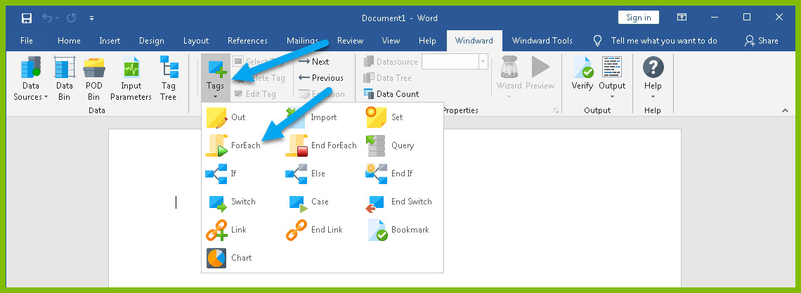
- Click enter to move to a new line, expand the drop down under the button “Tags” in the Windward ribbon, and click “EndForEach” to place a closing tag for the ForEach tag.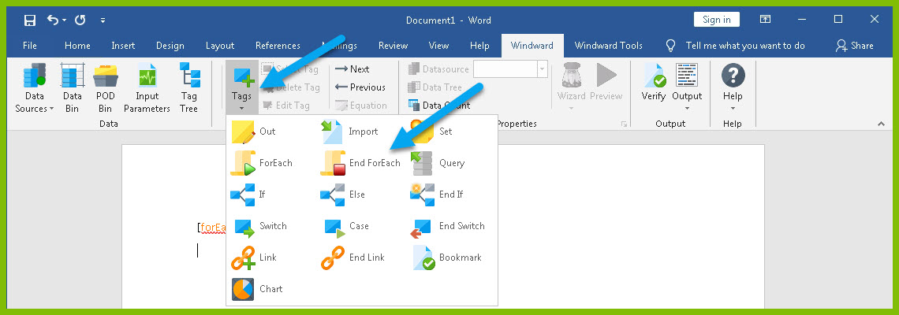
Now all of the content that you place between the ForEach and EndForEach tags will be generated once for each record returned by the ForEach tag’s select.
For the ForEach tag, you will select the Product node so that you can output information on each product.
- You can use the Tag Editor to easily create a query for your tag. Place your cursor on the “[forEach:]” tag that was inserted in your template and click the “Edit Tag” button in the Windward ribbon to open the Tag Editor.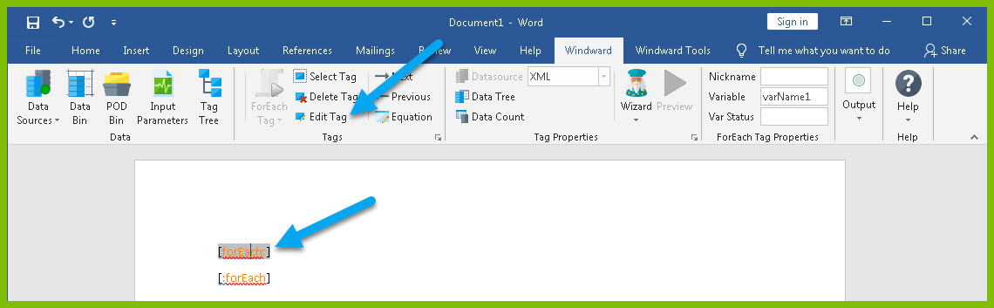
- In the Tag Tree, expand the node XML: SouthWind.xml -> windward-studios -> Product and double-click the “Products” node. This will automatically write a select for the Products node.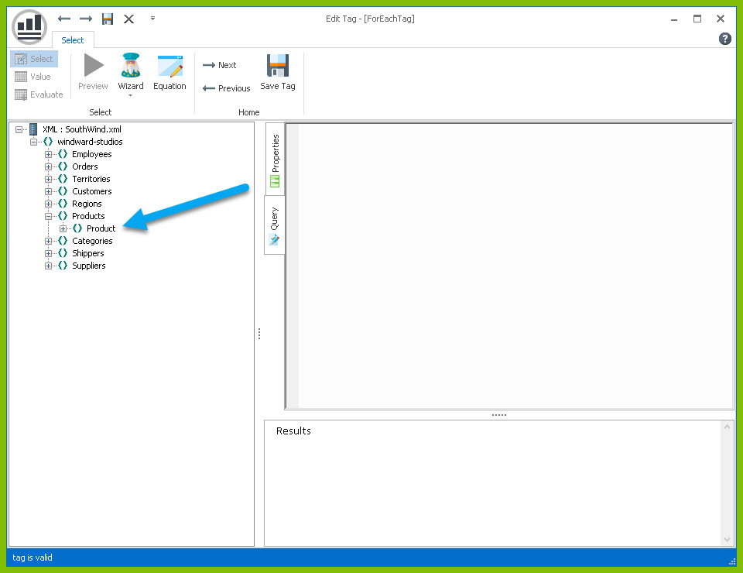
- Click the “Save Tag” button. Congratulations! You have just inserted your first tag into your template!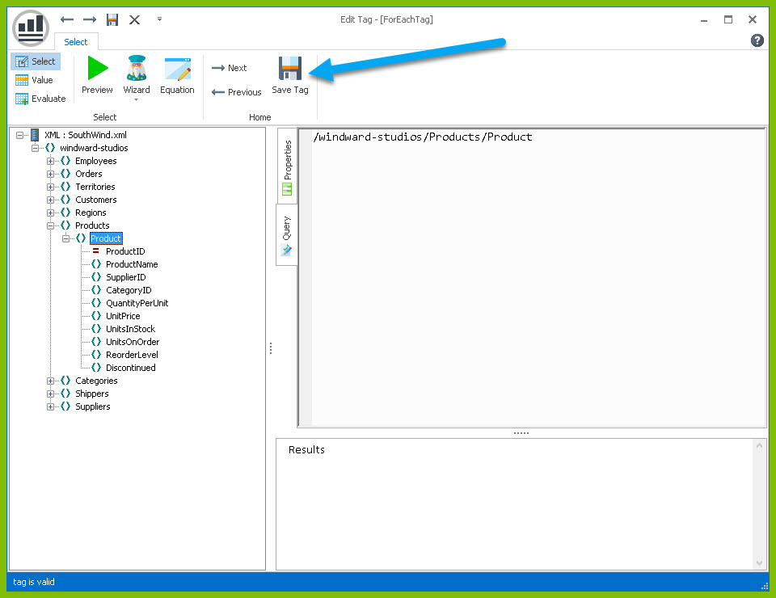
- On a new line after the ForEach tag, enter the text “Product Name:” and on the next line “Unit Price:”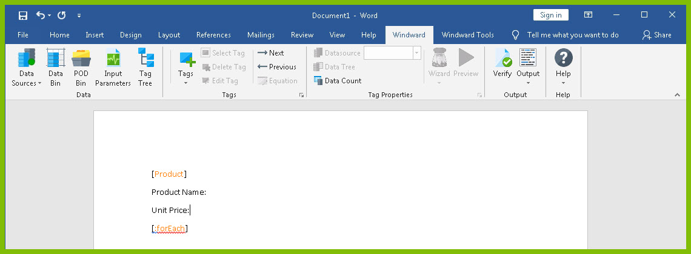
The “Product Name:” and “Unit Price” text will be output for every product returned by your ForEach tag’s select. Now you need to add the tags that will output the Product Name and Unit Price for each product after these labels. You do this using Out tags which will insert data into your final report.
- Place your cursor after the “Product Name:” text, and click “Tags” in the Windward ribbon and click “Out.” This places an Out tag in the template.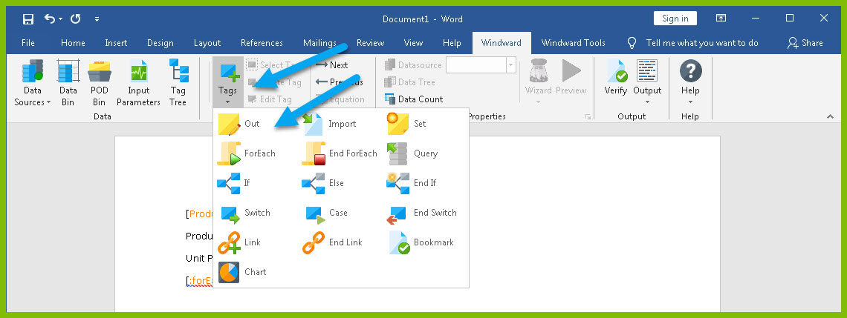
- Open the tag Editor by placing your cursor on the Out tag and clicking “Edit Tag.”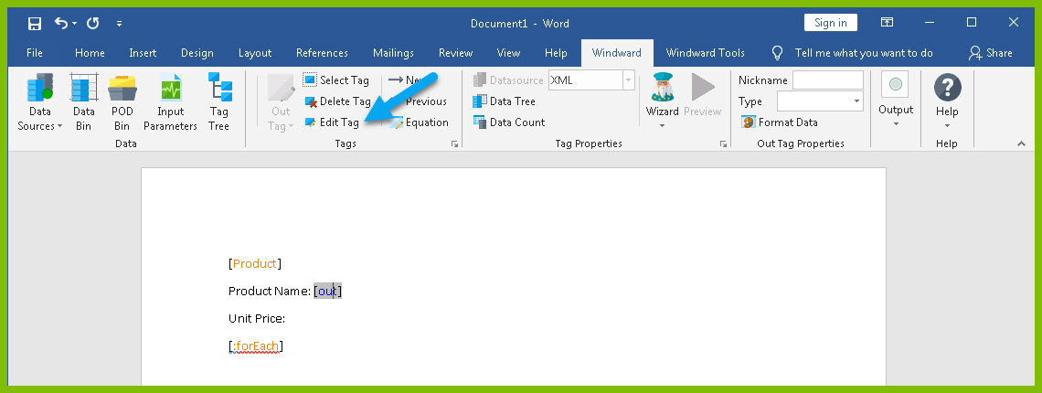
- You can now see your ForEach variable in the tag editor since the Out tag occurs in the template between the ForEach tag and the EndForEach tag. In the Tag Tree, expand <wr:forEach> -> Product and double-click ProductName. This automatically queries the ProductName currently held by the ForEach variable.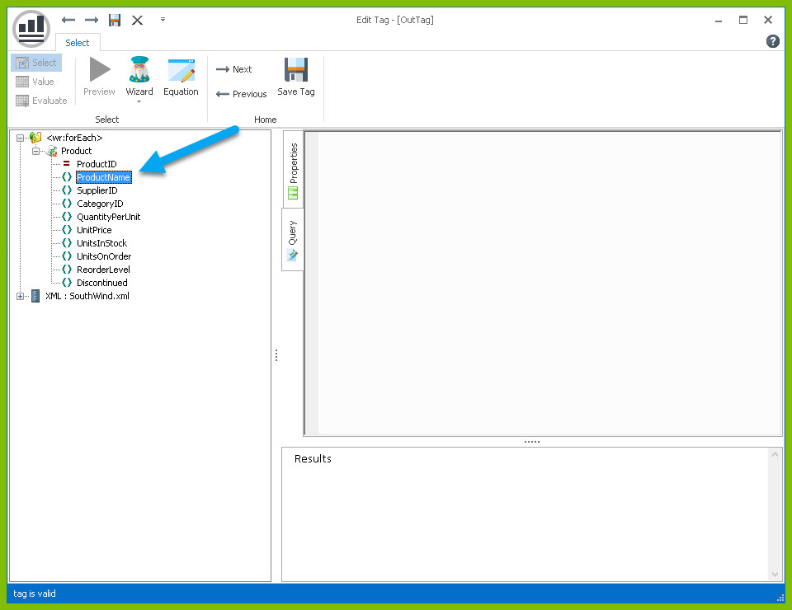
- Click “Save Tag” button to save your tag's query.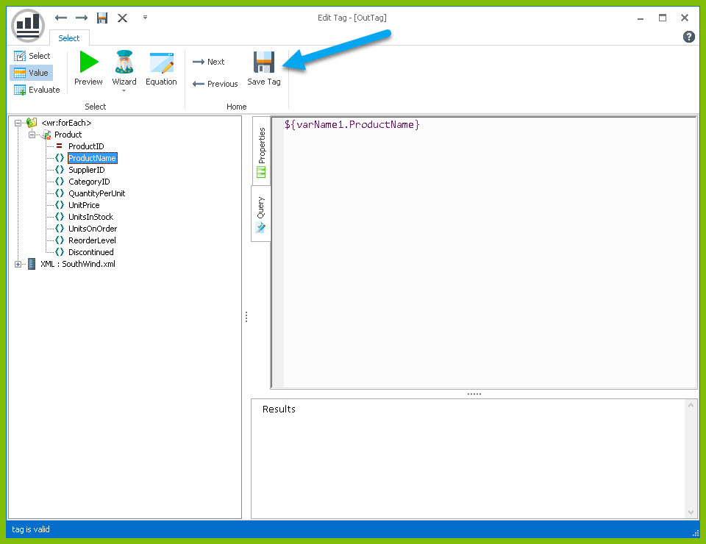
- Place your cursor after the “Unit Price:” text, and click “Tags” in the Windward ribbon and click “Out.” This places an out tag in the template.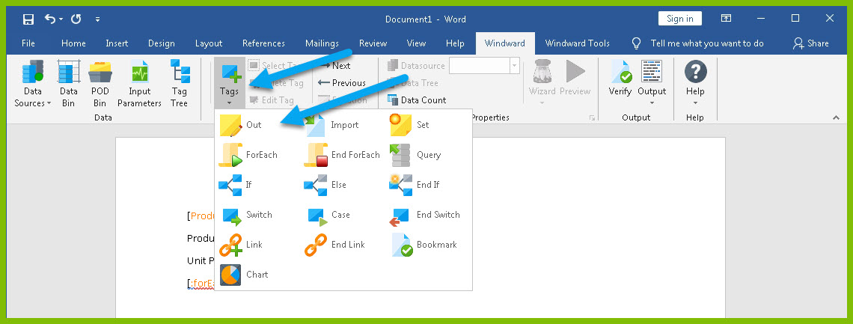
- Open the tag Editor by placing your cursor on the Out tag and clicking “Edit Tag.”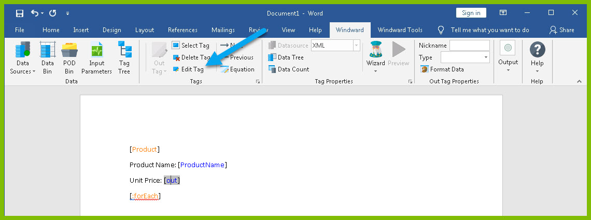
- You can now see your ForEach variable in the tag editor since the Out tag occurs in the template between the ForEach tag and the EndForEach tag. Expand <wr:forEach> -> Product and double click UnitPrice. This automatically queries the UnitPrice currently held by the ForEach tag.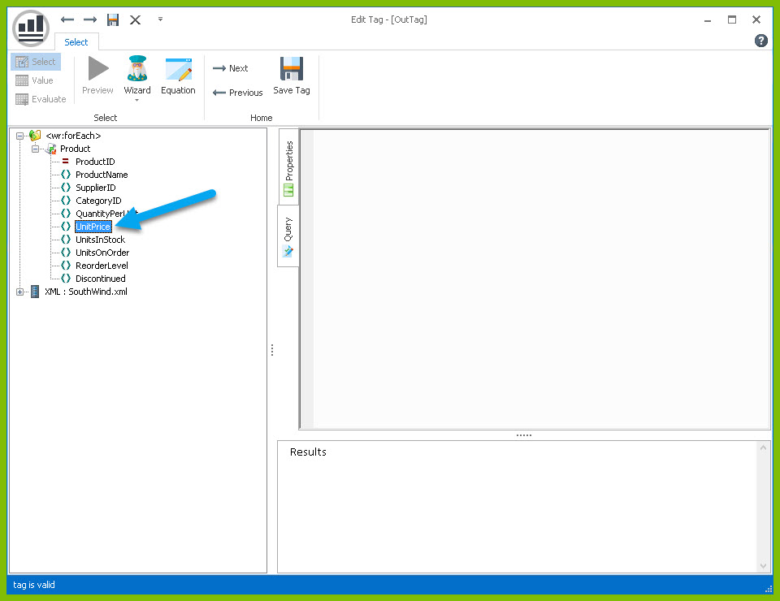
- Click the “Save Tag” button to save your tag's query.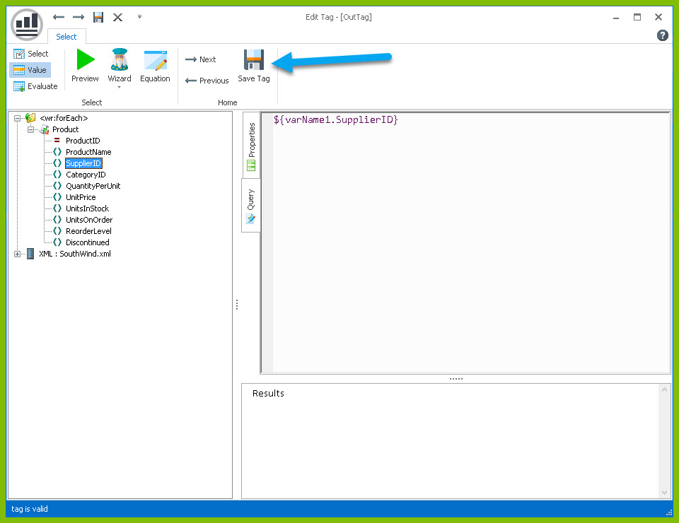
Finally, add some indicator between each product so you can easily distinguish between them in your output.
- Indent to a new line after the line starting with “Unit Price:”
- Add a horizontal line by typing “---” and pressing Enter. This will create a line across the document followed by an indentation. 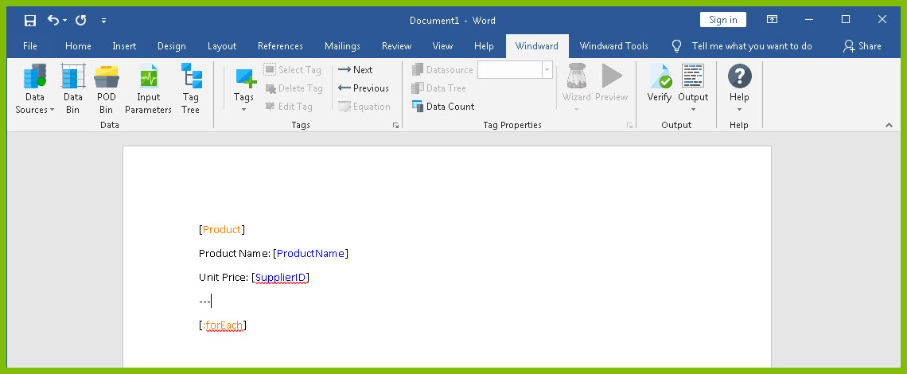
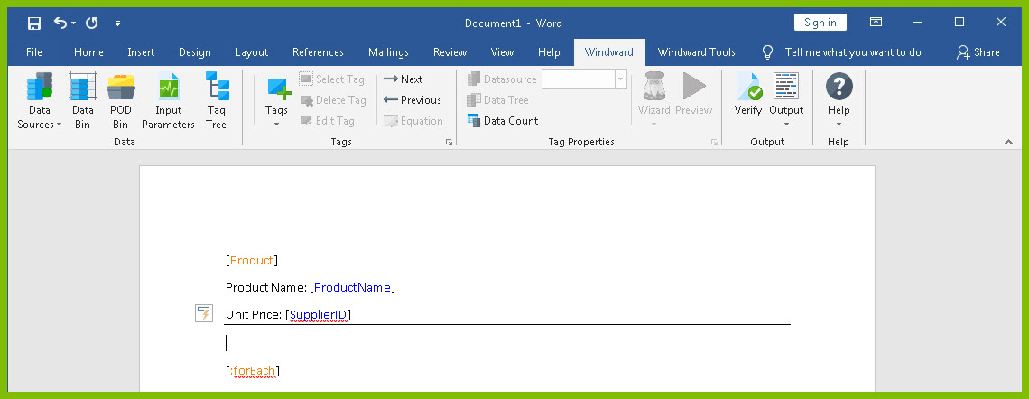
Now you are all finished with your template design!
Step 4: Output
1. Save your template. You can save your template to anywhere you want on your machine and give it any name you want. Be sure to save it as a “.docx” document.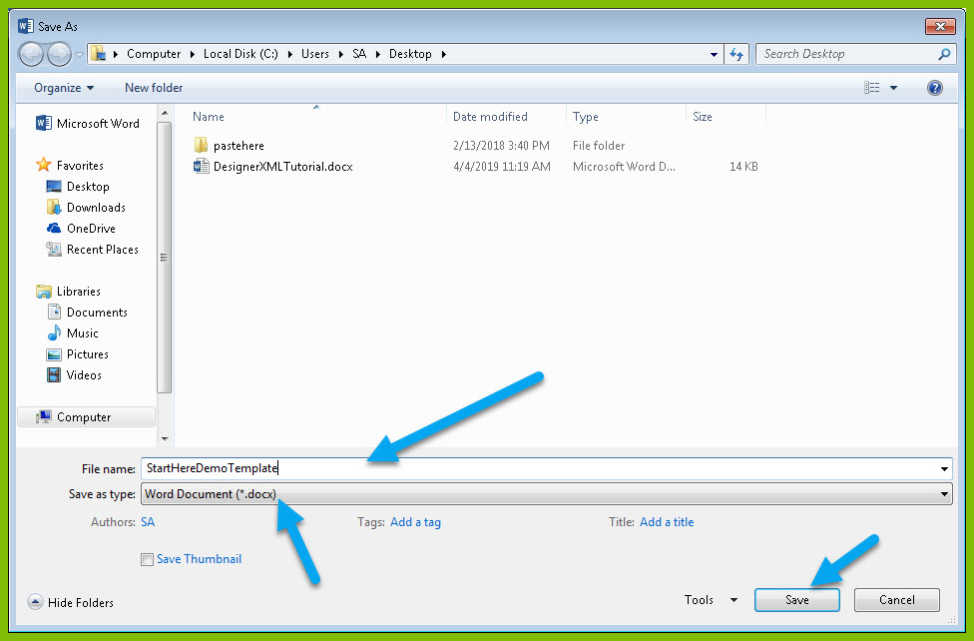
2. In the “Windward” tab, click the “Output” button and from the drop down select “DOCX.”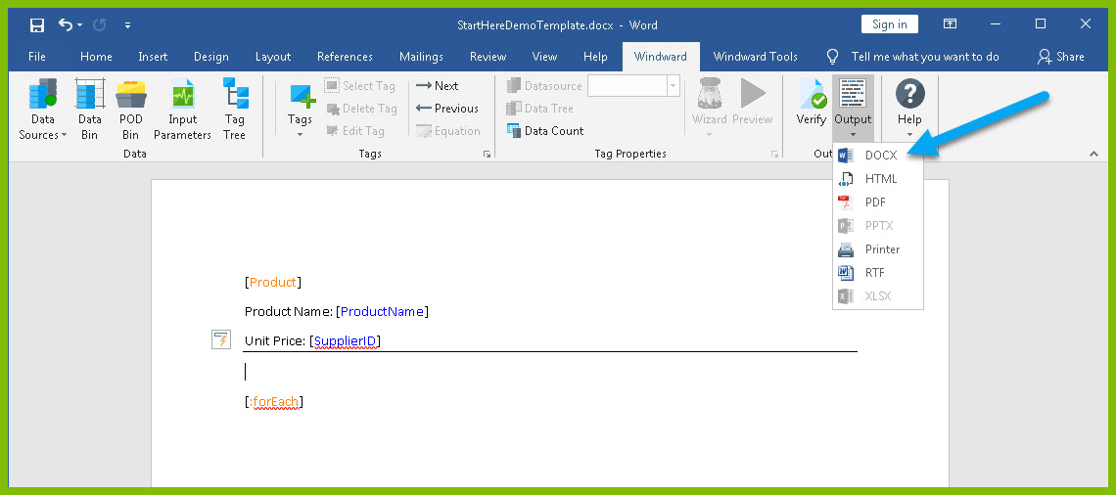
Your template will output, and you should see a list of product names and their unit price with each product separated by a line.
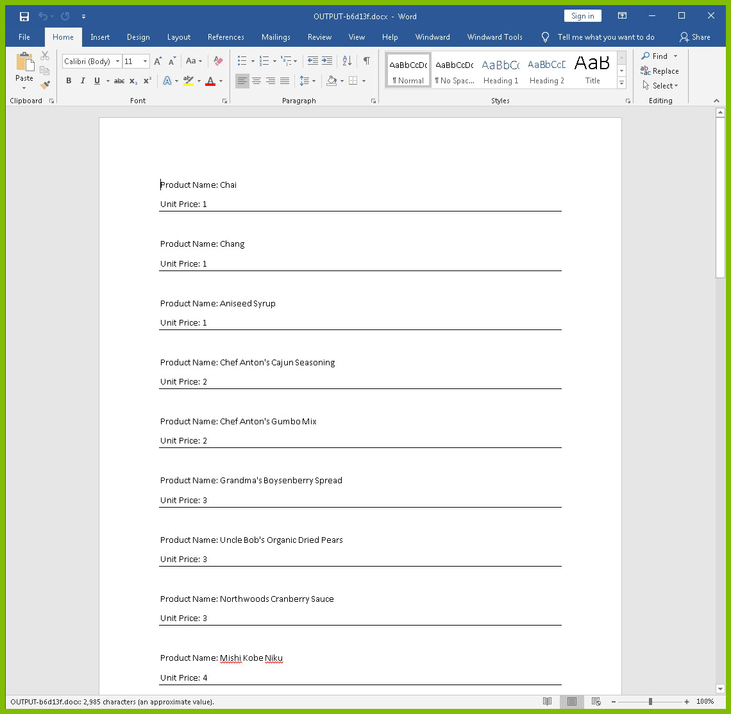
Congratulations! You have created your first template in Windward Designer and produced your first output!
Next Steps:
Now that you have finished this introduction tutorial, here are some resources we recommend you visit next:
- How to connect to XML datasources
- How to use the XPath Wizard
- The Windward Tutor: A collection of short video tutorials

